Meet Me at the Albany - Membership form
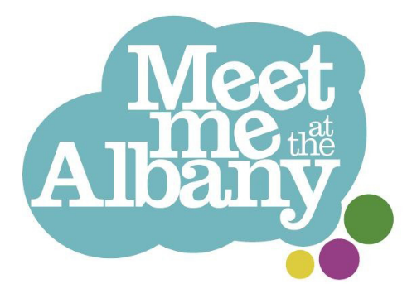
Meet Me at the Albany is an artist-led club for people over the age of 65, offering weekly groups running on the telephone and out of The Albany in Deptford.
We welcome people who are living with long-term health conditions or dementia. Please let us know if you have any access requirements or there is anything we can do to help you take part.

Applicant Details
First name:  …………………………………….. | Last name:  ……………………………………..
What do you like to be called:  …………………………………….. | Date of Birth:  ……………………………………..
Address:  …………………………………….. | Phone number:  ……………………………………..
How do you prefer to be contacted?  (for example, by phone call or WhatsApp)  …………………………………….. | Preferred Pronouns:  (for example he/ him, or they/ them)  ……………………………………..

Interests
Please circle all you are interested in!


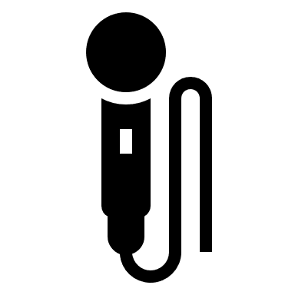

Anything else?:

……………………………………..

Transport Details
How would you get to our activities?

……………………………………..……………………………………..

If you are unsure or if you need support getting to the groups, please tick here: ☐

Support Needs
Do you get around: | ☐ Independently  ☐ With a walking stick or mobility aid  ☐ With support from somebody  ☐ In a wheelchair  Any further details:  ……………………………………..
Is there anything you would like us to know so that we can support you best? (such as mental or physical health needs you would like to make us aware of)

Yes (please give further details) ☐ No ☐

……………………………………..……………………………………..

Unfortunately our groups aren’t appropriate if you need support with: eating, toileting or taking medication.

Please tick here to confirm you can toilet, eat and take medication independently ☐

Our groups can last for more than 2 hours. If you use incontinence pads, please make sure you can remain comfortable for the duration of the stay if you aren’t able to change them (we can’t support with this). If this is the case, we may ask to speak to your care company in order to ensure your hygiene and health is put first.

Do you have any dietary requirements or allergies? | ☐ No  ☐ Yes (please give details):  ……………………………………..

Emergency Contact
Name and number of someone we can call in emergencies:

……………………………………..……………………………………..

Your Consent
Your data will be stored safely, separately and confidentially on our central database. Please let us know if you would like to see our privacy statement

I am happy for Entelechy Arts and The Albany to store my details in their database.
Signature:  …………………………………….. | Date:  ……………………………………..

Thank you for completing the above!
Please return this form to:

: jasmine.sparrow@entelechyarts.org
+ Entelechy Arts, The Albany, Douglas Way, London SE8 4AG
( 07593 580574 (for queries and access requests, or to go through this form over the phone)


Meet Me is led by Entelechy Arts and the Albany and supported by Lewisham Council, City Bridge Trust and Independent Age.


