Meet Me at the Albany - Referral Form
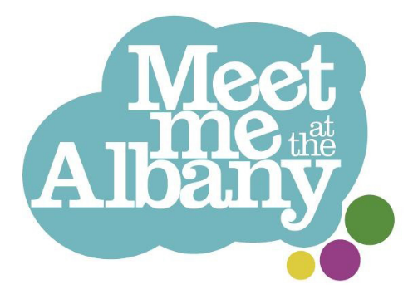
Meet Me at the Albany is an artist-led club for people over the age of 65, offering weekly groups running on the telephone and at The Albany in Deptford.
We welcome people who are living with long-term health conditions or dementia. Please let us know if you have any access requirements or there is anything we can do to help you take part.

Participant Details
First name:  Click or tap here to enter text. | Last name:  Click or tap here to enter text.
Known as:  Click or tap here to enter text. | Date of Birth:  Click or tap to enter a date.
Address:  Click or tap here to enter text. | Phone number:  Click or tap here to enter text.
How do they prefer to be contacted? | Preferred Pronouns (if known):  Choose an item.  Click or tap here to enter text.

Reason for referral
For example is there a particular group they are interested in, or are they isolated and looking to meet new people?
Click or tap here to enter text.

Support Needs and Transport
Do they mobilise: | ☐ Independently  ☐ With a walking stick or mobility aid  ☐ With support from somebody  ☐ In a wheelchair  Any further details:  Click or tap here to enter text.
We use Community Connections Lewisham (CCL) and their transport service to get people to and from our groups. This costs participants £10 return journey from anywhere in Lewisham, using a regular car. However this service is currently oversubscribed and we are running a waiting list. We would encourage members to try alternative means of transport where possible such as taxicard or dial a ride schemes. Otherwise members make their own way.

Please tick if they would like to join the waiting list for CCL or require advice regarding transport☐

Does the person have any support needs, or any mental or physical health issues that we need to be aware of?
Yes ☐ No ☐
If ‘Yes’ please provide further details:
Click or tap here to enter text.

Are there any risks posed by them coming to our groups or to transport companies picking them up from home?
Yes ☐ No ☐
If ‘Yes’ please provide further details:
Click or tap here to enter text.

Unfortunately our groups aren’t appropriate for people who need support with: eating, toileting or taking medication. Please tick to confirm they don’t need assistance with toileting, eating and taking medication ☐

Do they have any dietary requirements? |  | ☐ No  ☐ Yes (please give details)  Click or tap here to enter text.

Relevant Contacts
Emergency contact full name:  Click or tap here to enter text. | Emergency contact number:  Click or tap here to enter text.
Can we contact this person to find out more about the person you are referring?
Choose an item.
If there is anyone else we should speak to please put their details here:
Click or tap here to enter text.

Referrer Details
Your name:  Click or tap here to enter text. | Contact number:  Click or tap here to enter text.
Email address:  Click or tap here to enter text. | Organisation:  Click or tap here to enter text.
Please confirm that the above person has consented to be referred: ☐
Choose an item.

Thank you for completing the above!
Please return this form to:

: jasmine.sparrow@entelechyarts.org
+ Entelechy Arts, The Albany, Douglas Way, London SE8 4AG
( 07593 580574 (for queries and access requests, or to go through this form over the phone). Please note my normal working hours are 9am-5pm, Monday to Wednesday.



Meet Me is led by charities Entelechy Arts and the Albany. The programme is supported by Lewisham Council, National Lottery Reaching Communities fund as well as independent trusts and foundations.

